1. Created a database called mongodb_practice

Command: use mongodb_practice

1. Inserting the documents into movies collection. To create a collection the command used is db.createCollection(“Collection_Name”)

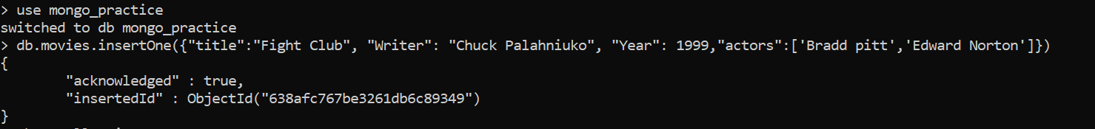

Inserting many documents into the collection the command is as follow

db.movies.insertMany({[document]})



1. Get all documents

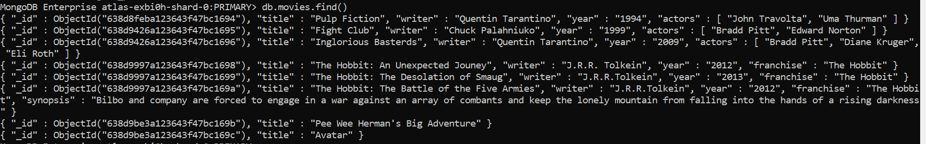

1. Get all documents with writer set to “Quentin Tarantino”



1. Get all documents where actors include “Brad Pitt”



1. Get all documents with franchise set to “The Hobbit”



1. Get all movies released in 90s



1. Get all the movies released before the year 2000 or after 2010

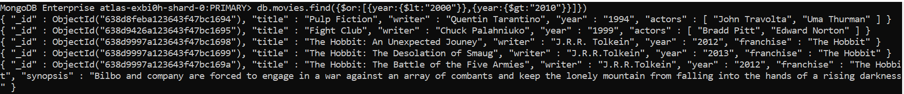

Add a synopsis to “The Hobbit: An unexpected Jounrney”

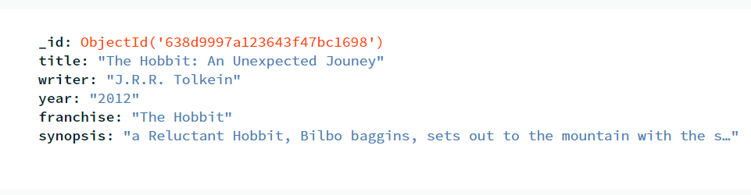

Add a synopsis to “The Hobbit: The Desolation of Smaug”



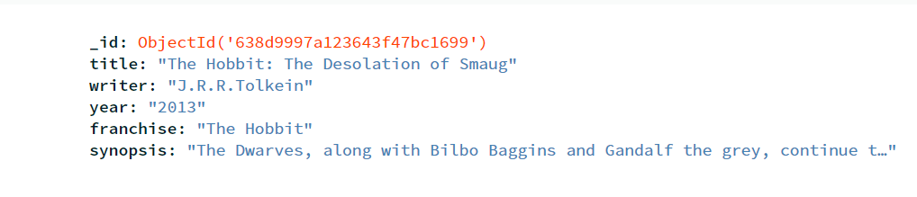

Add an actor named “Samuel L.Jackson” to the movie “Pulp Fiction”



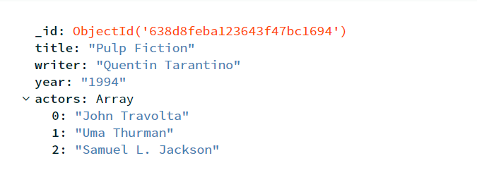

Find all movies that have a synopsis that contains the word “Bilbo”

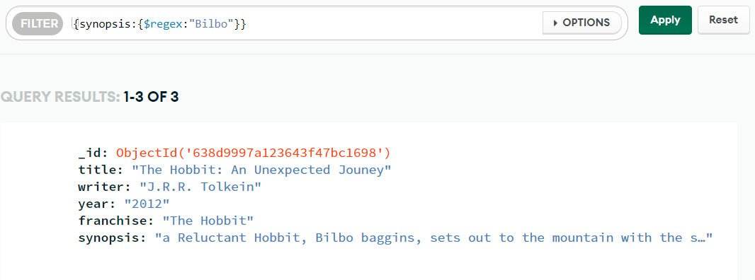

Find all movies that have synopsis that contains the word “Gandalf”

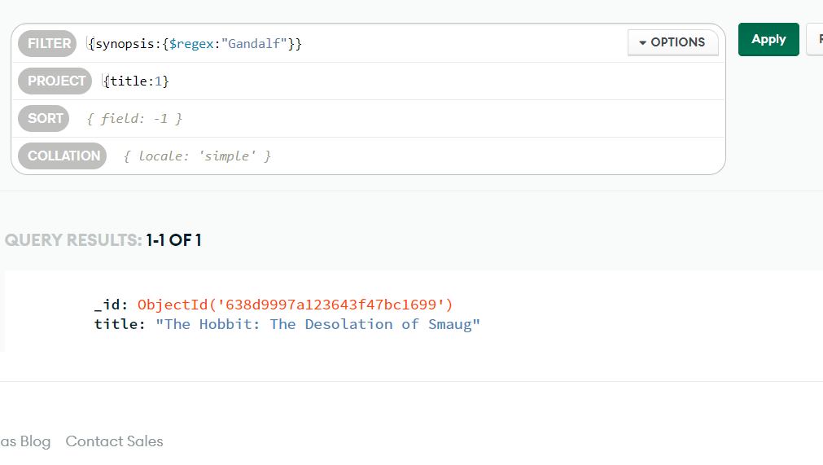

Delete Documents

Delete the movie “Pee Wee Herman’s Big Adventure”

Delete the movie “Avatar”



